Co-pathology syn and tau hippocampal injection

Project goals:
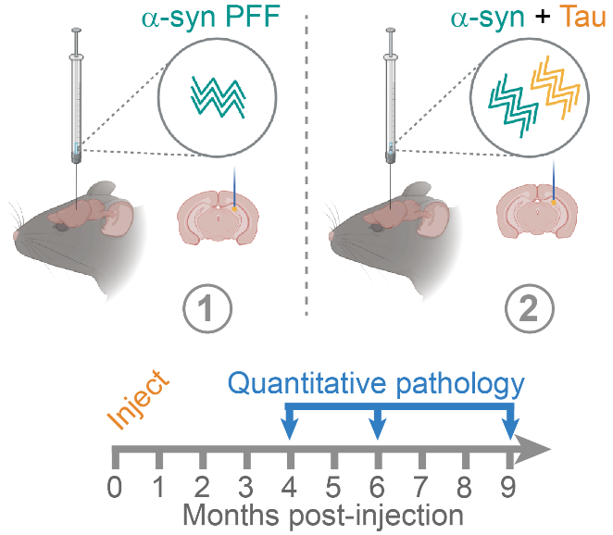
- Determine the impact of tau co-pathology on the development and progression of α-synuclein pathology.
- Determine the differential regional and cellular vulnerabilities to tau and α-synuclein pathology when mice are injected at the same time and same place.

Experimental Design
- Mice injected with either α-synuclein PFFs alone, or α-synuclein PFFs and Alzheimer's disease tau in the hippocampus.
- Mice aged 4, 6, or 9 months post-injection.
- Tau and α-synuclein pathology quantified throughout the brain.

Network analysis goals:
- Tau and α-synuclein pathology linear diffusion modeling in two groups of mice (α-synuclein PFF alone vs. α-synuclein PFF + AD tau. Each with 2 pathologies (α-synuclein and tau).
- Determine the impact of tau on development of α-synuclein pathology (fit parameters).
- Vulnerability mapping for α-synuclein vs. tau.
- Injection sites: CA3, CA1, DG

We can see clearly that overall α-synuclein pathology is reduced when co-injected with tau. We can also see that tau goes to regions that α-synuclein does not, indicating differential vulnerability.

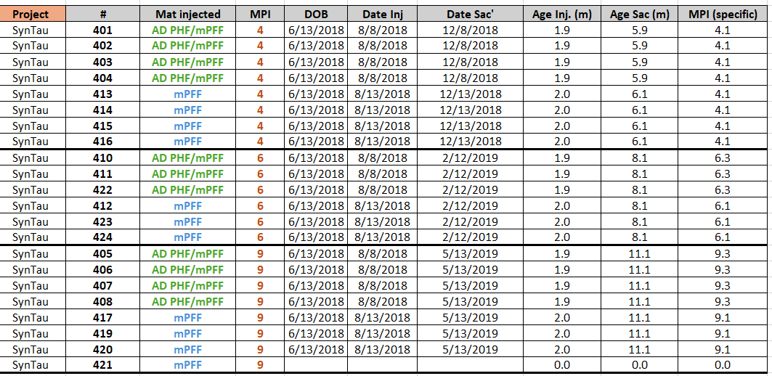
Mice list:

pSyn load

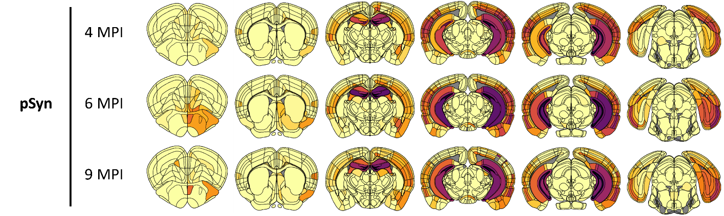

mPFF

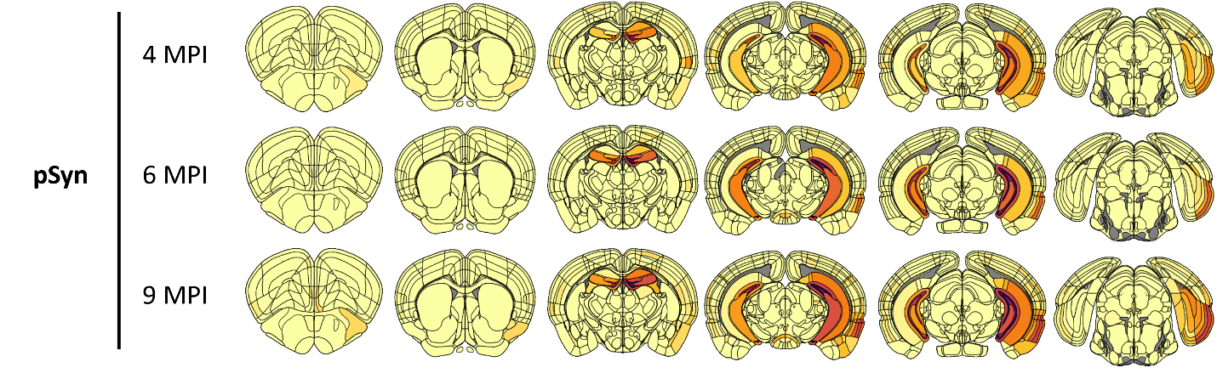

mPFF
+
AD PHF

pTau load

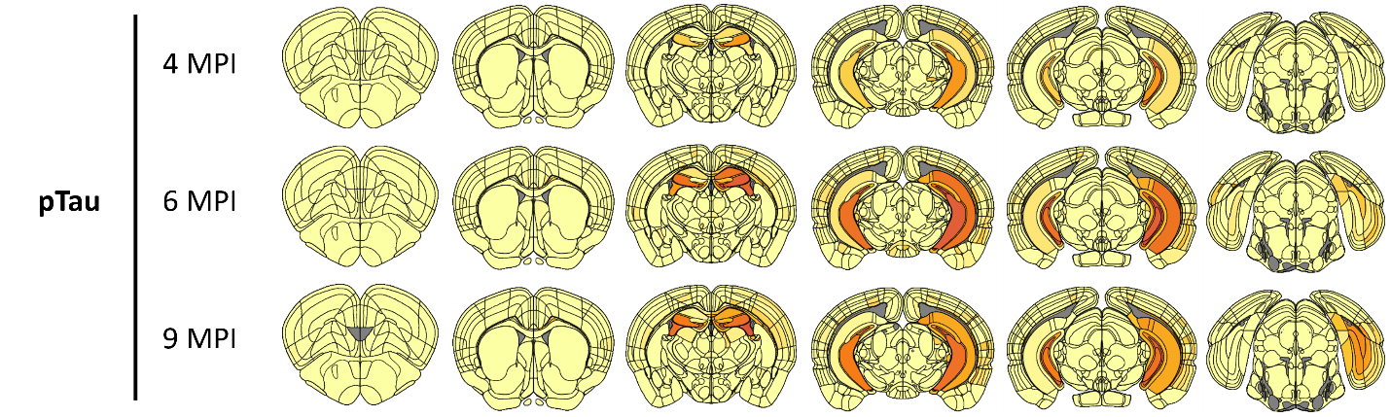

mPFF

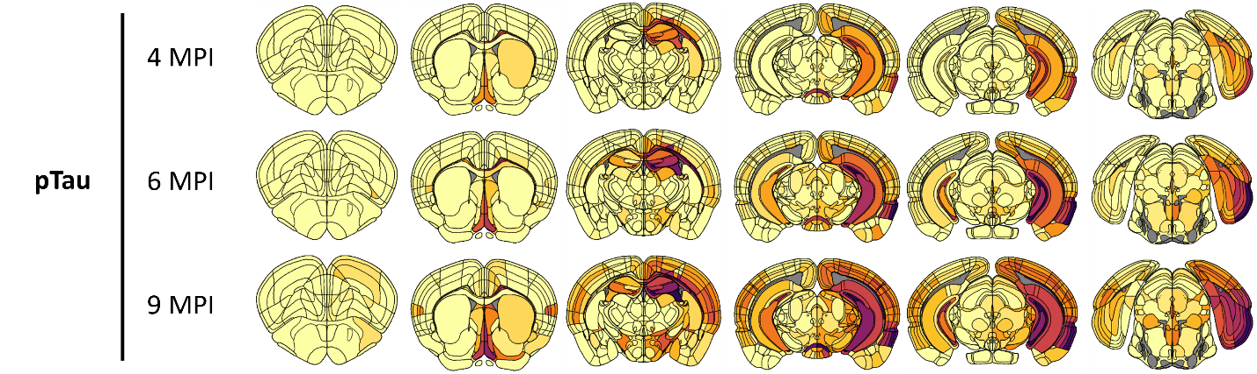

mPFF
+
AD PHF

